Guide to Pre-ordering Flowers

Last Revised April 6, 2022

Market Day: is on Tuesday, cease preorder sales on Saturday night. Preorder opens on Wednesday at 6:00 am

# Webapp Overview

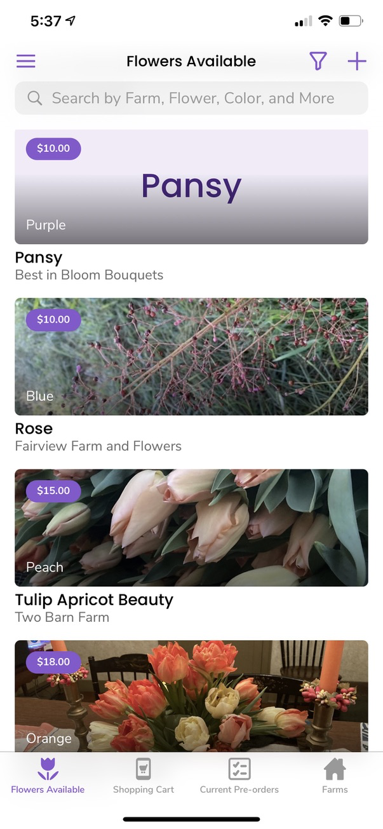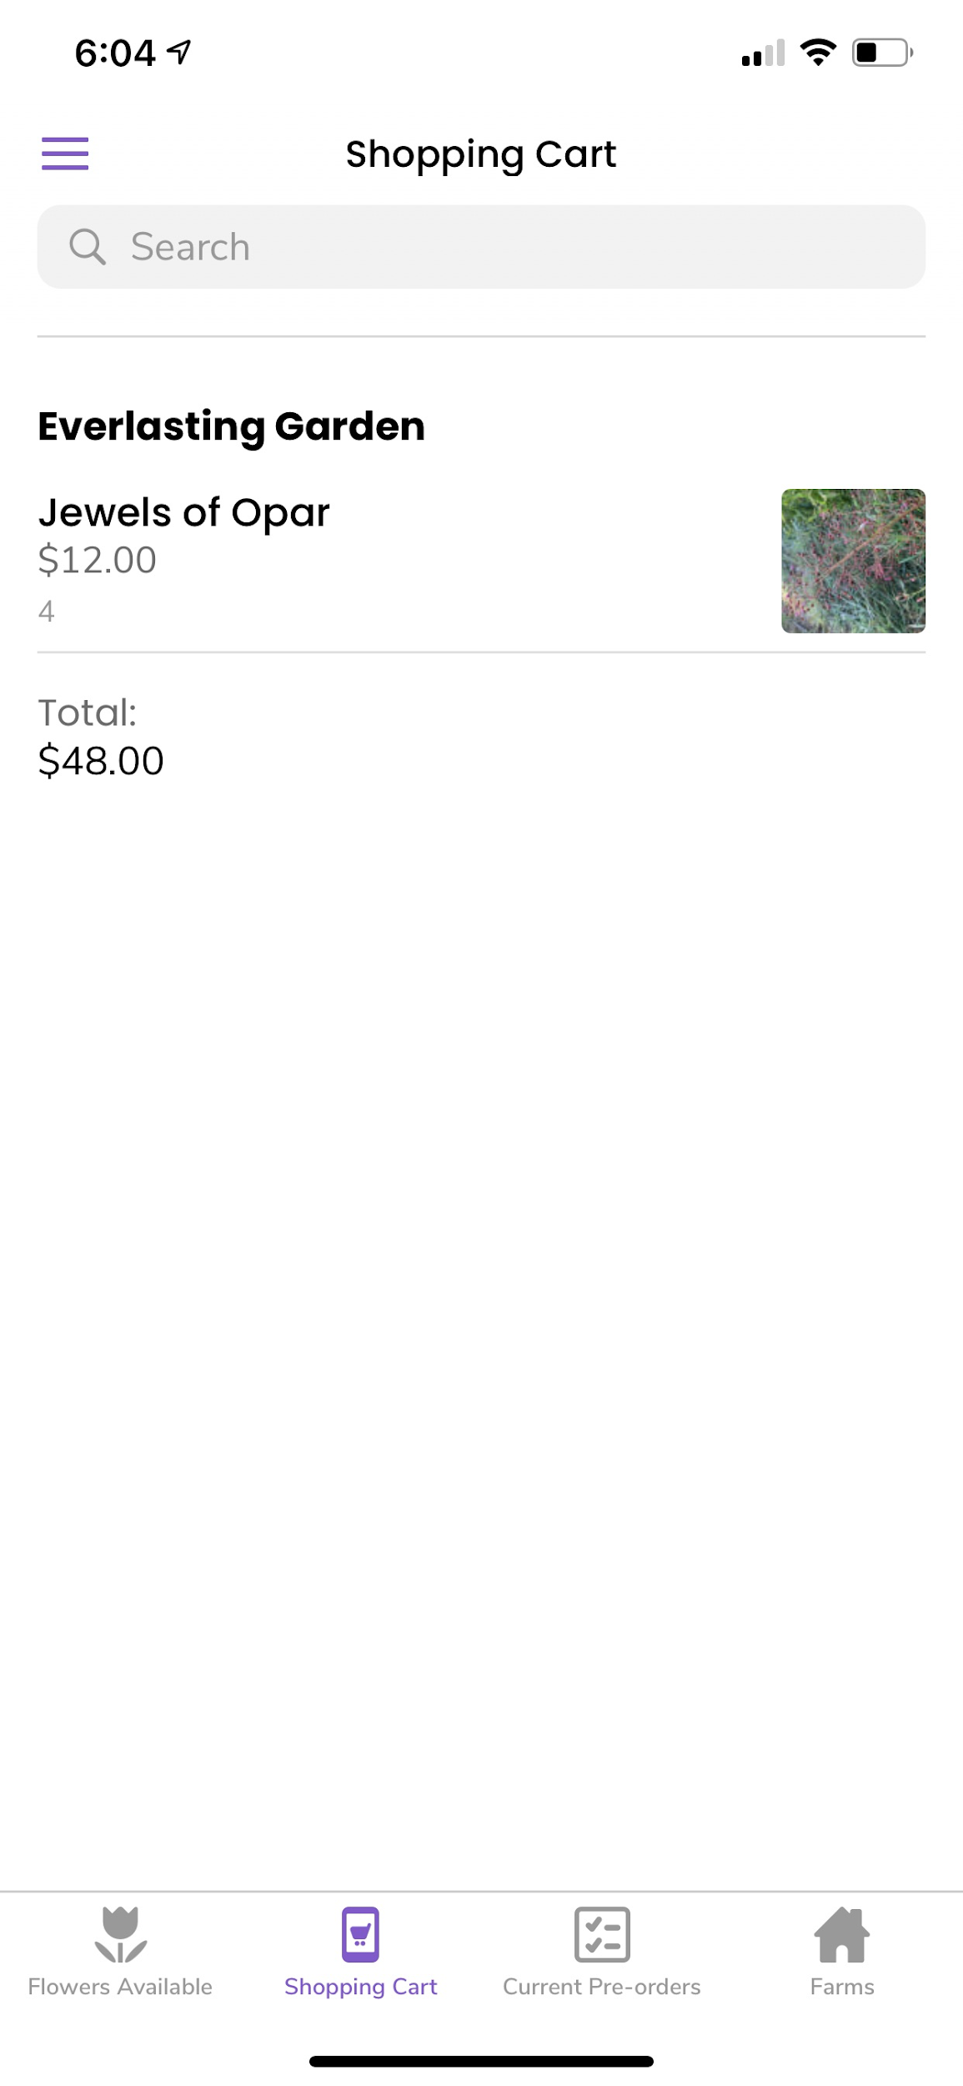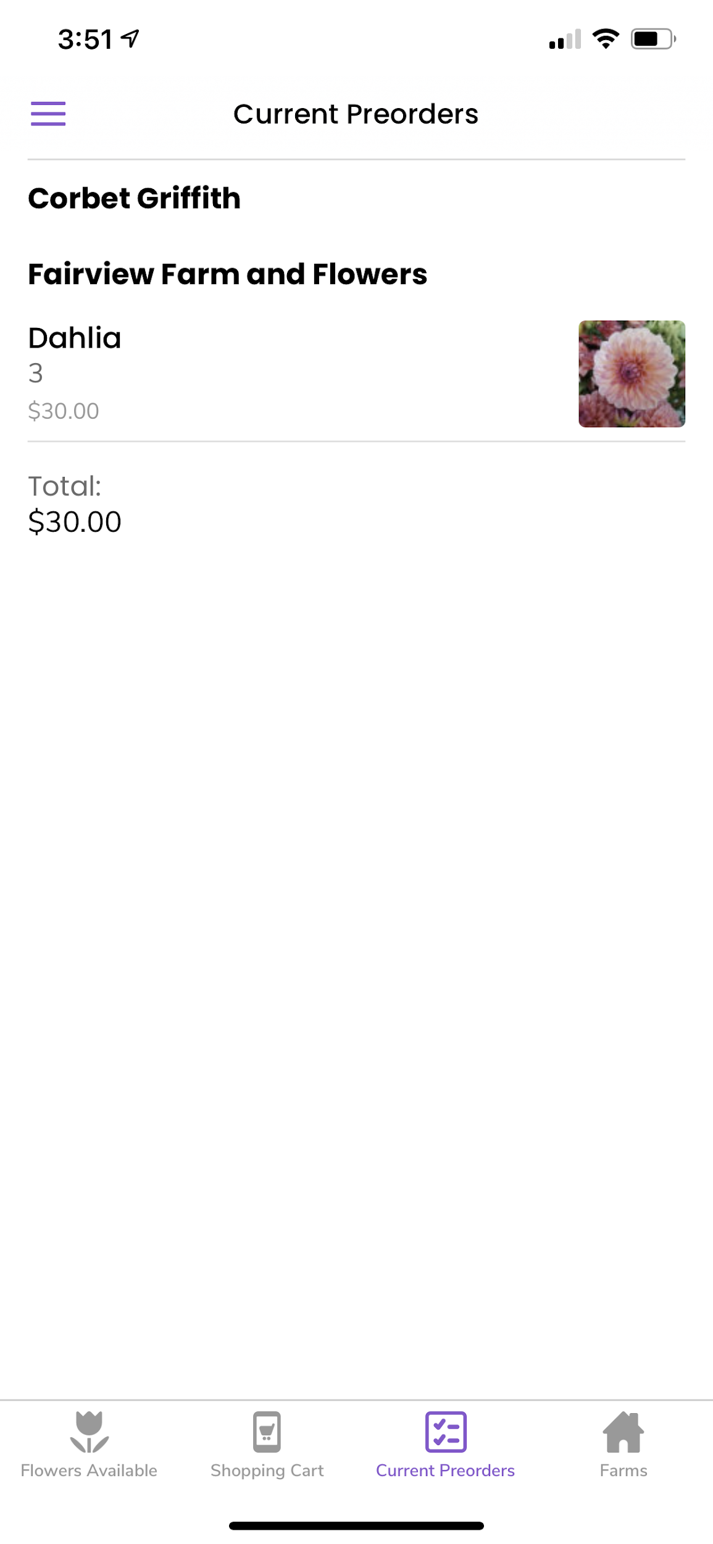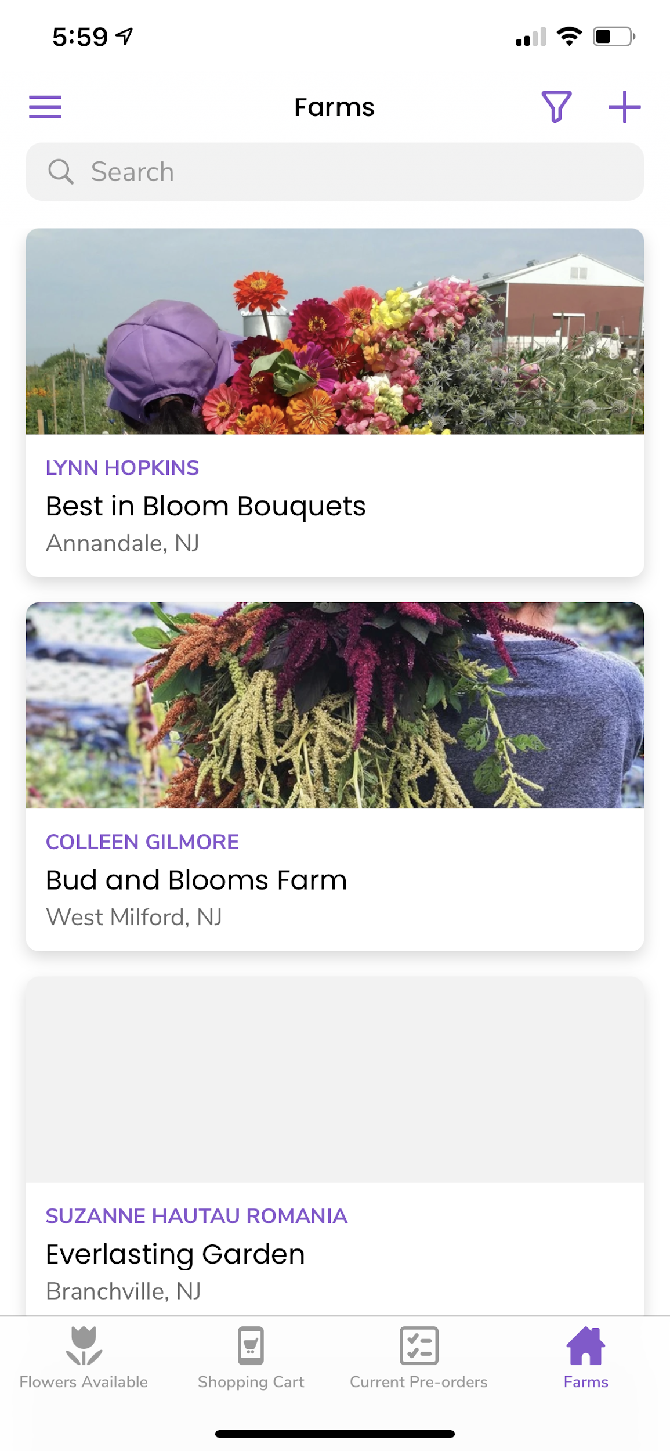

**Growers:**

* Optimized for mobile, tablet, and laptop devices
* Easily add inventory for the upcoming market day in the **“Flowers Available”** section
* View and prepare pre-orders for the upcoming market day in the **“Fulfill Pre-orders”** section
* Review and audit past orders that have already been fulfilled in the **“Completed Pre-orders”** section

**Designers:**

View available flowers and add items to your shopping cart for the upcoming market day in the **“Flowers Available”** section

* Edit and Finalize preorders for the upcoming market day in the **“Shopping Cart”** section
* Review your finalized preorders in the **“Current Pre-orders”** section
* Get more information about the growers in the **“Farms”** section

# How to Access the Flower Preorder Webapp

## Mobile/Tablet:

From your device’s camera, take a photo of QR code or go to:

<https://gardenstate.glideapp.io/>

## Desktop Computer:

Go to<https://gardenstate.glideapp.io/>

# Saving the App to Your Mobile Device

When you first access the website through the QR code or link, you should be prompted to add the application to your devices home screen, which easily allows you to access the preordering app from your phone.

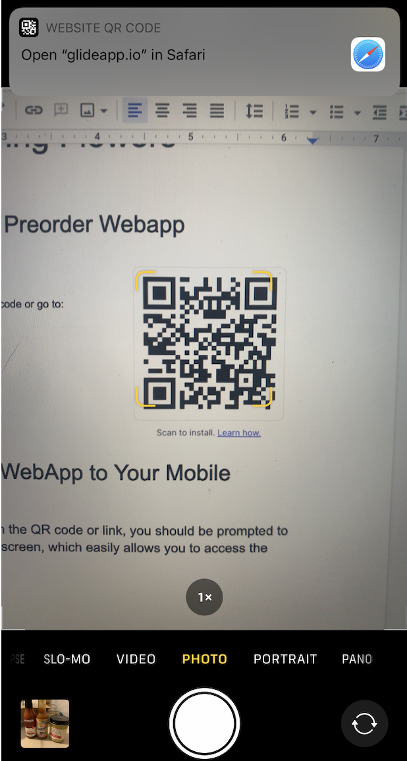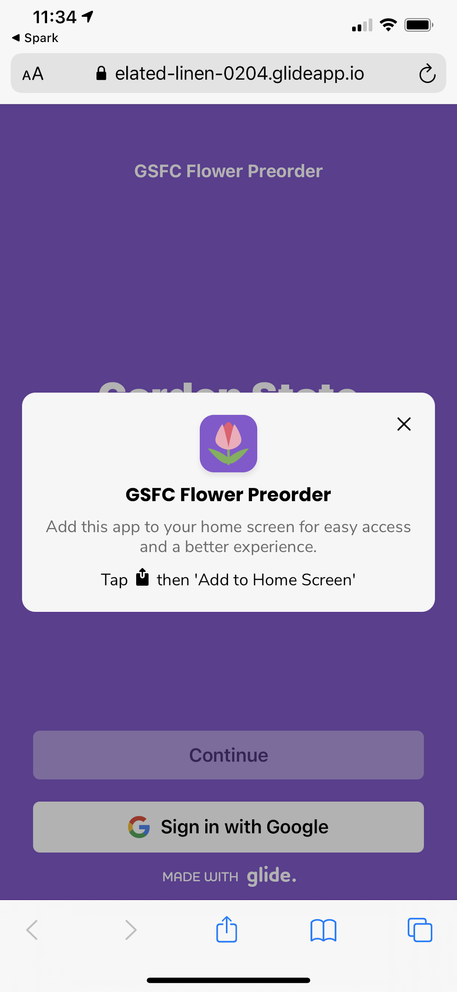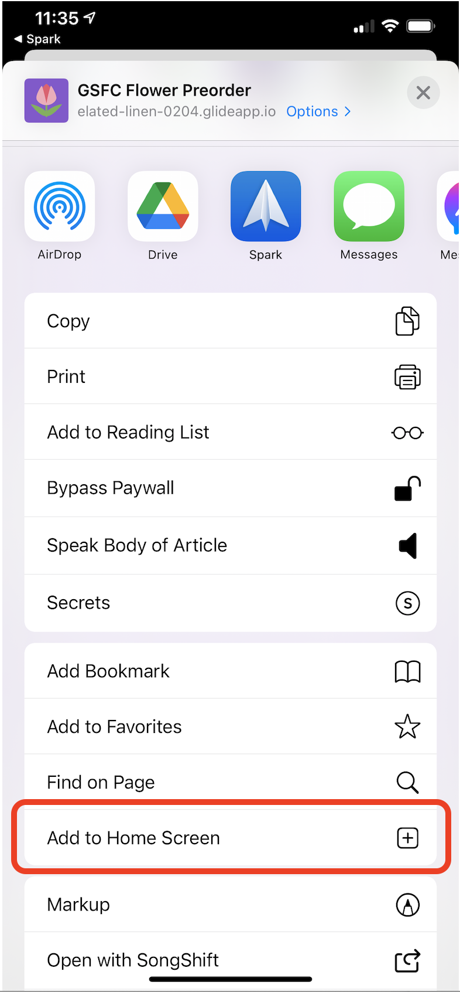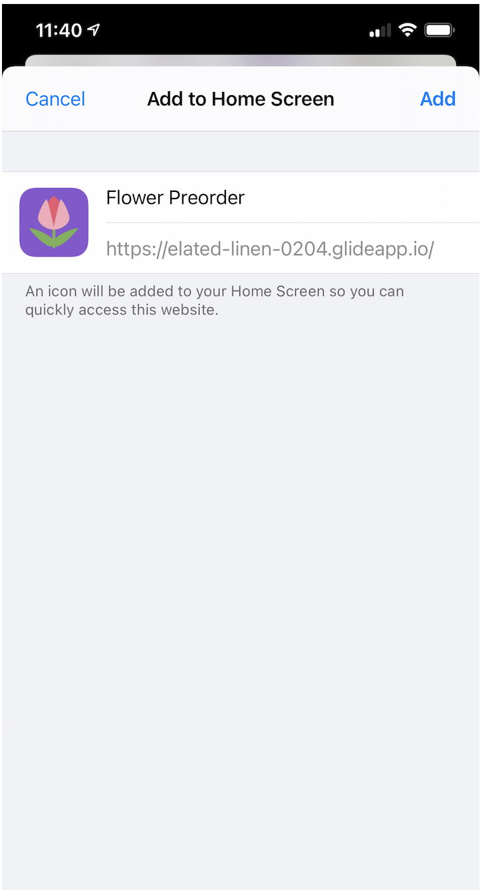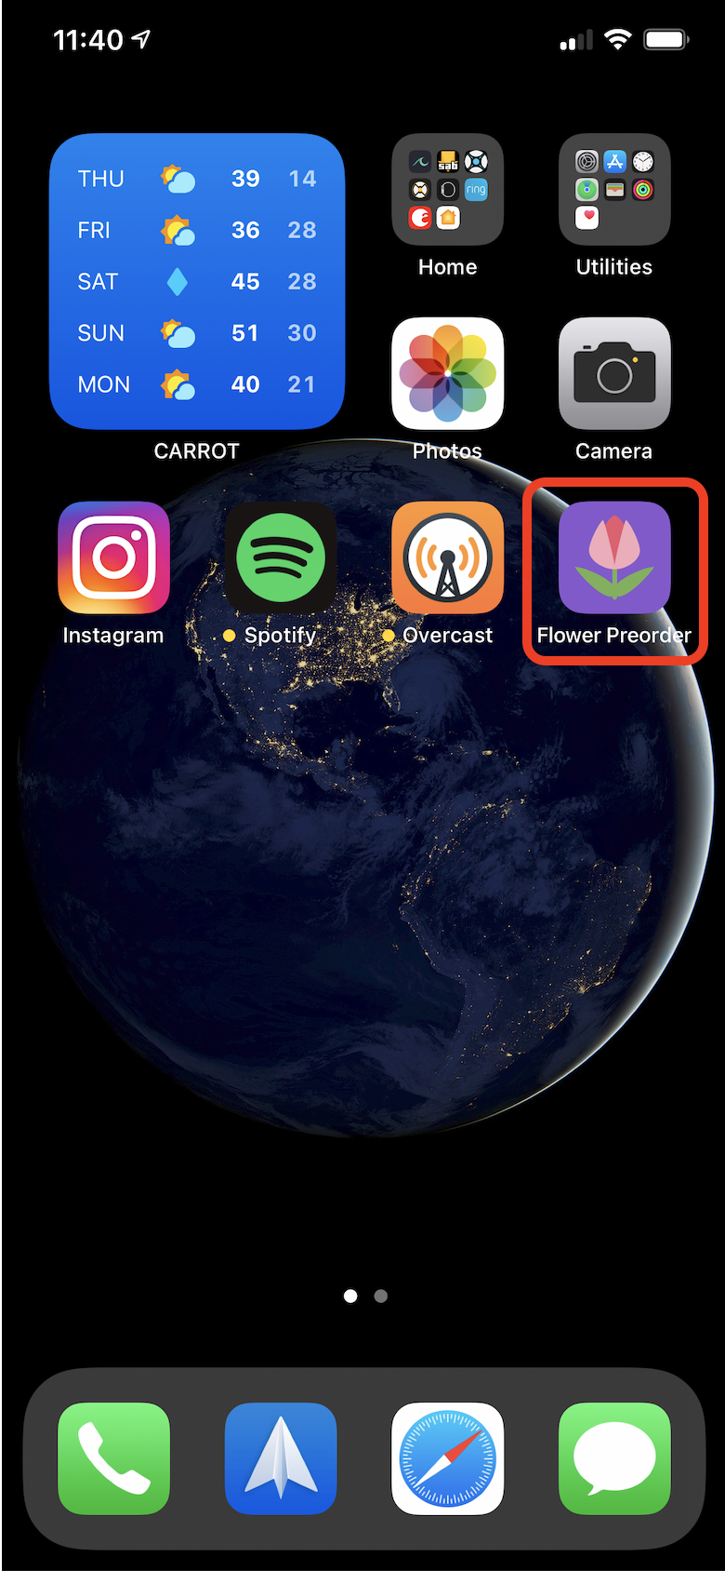

# Signing in:

Users must enter their e-mail address and receive a pin in order to sign in - this enhances the security and allows us to tie preorders to users.

**Note:** If you add the webapp to your device’s home screen, your login information will be saved and you will not be required to login again.

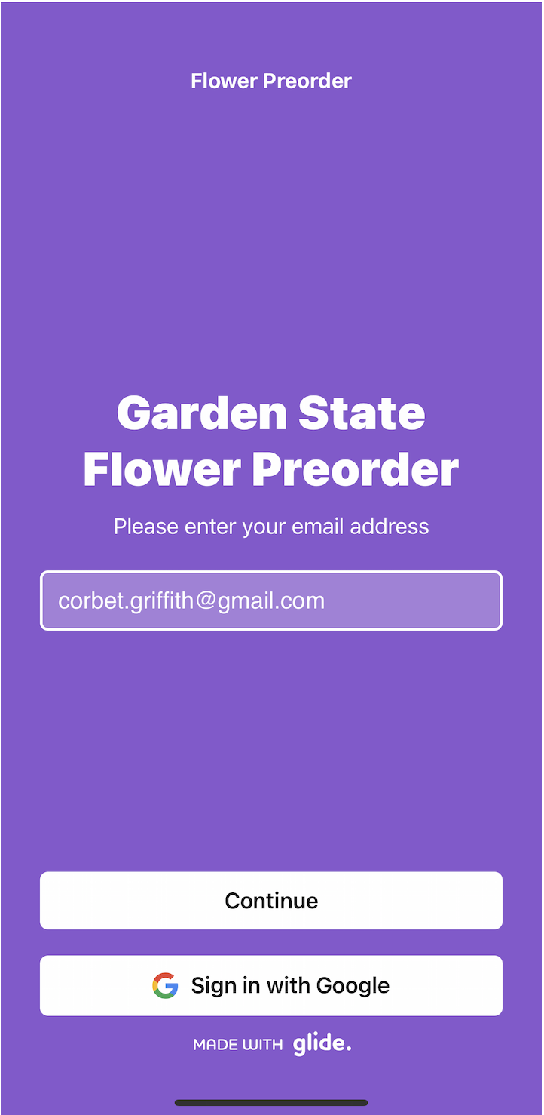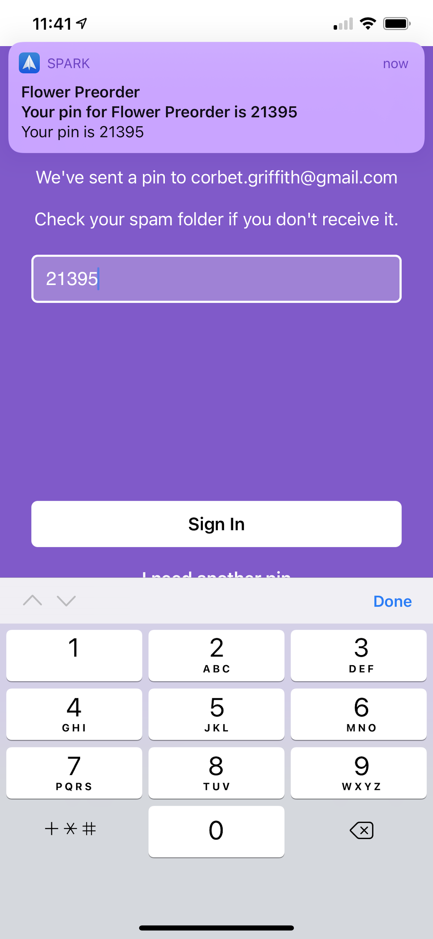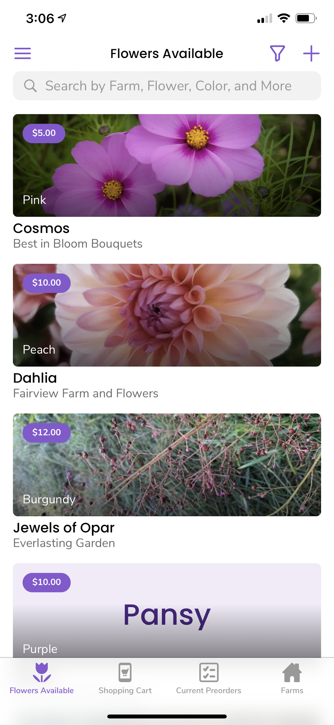

# 

# **Growers:** How to Add Flowers for the Upcoming Market Day

From the “Flowers Available” sceen, growers can easily select the “Add” button to add new inventory for the upcoming market day. This new inventory can only be preordered by designers between Wednesday at 6:00 am and Saturday at 11:59 pm when the ‘Add to Cart’ button will be available.

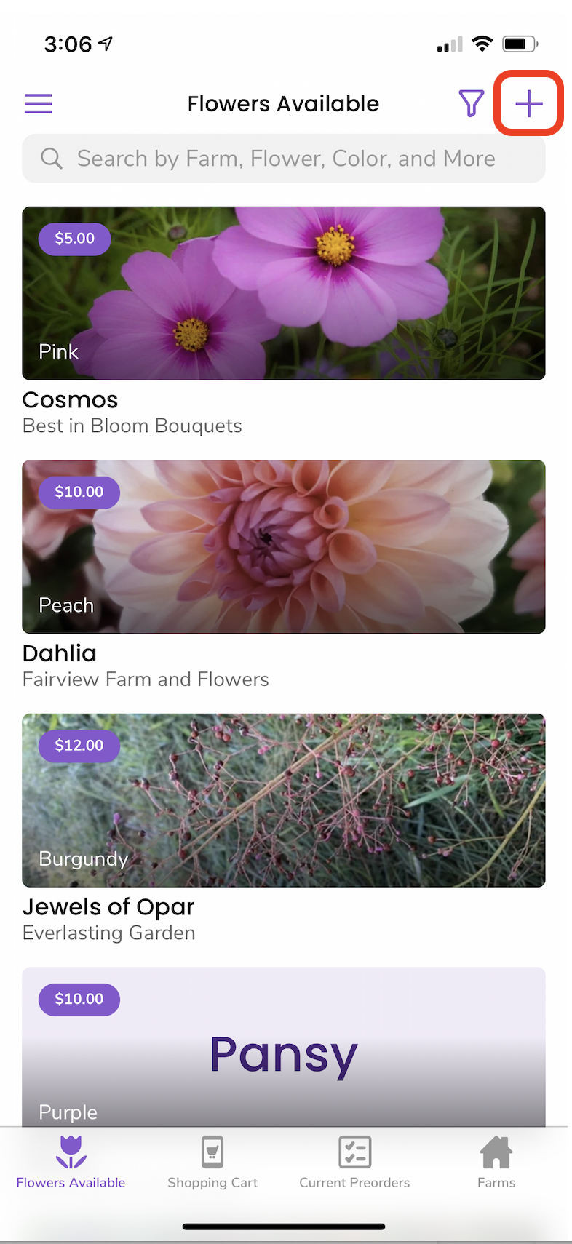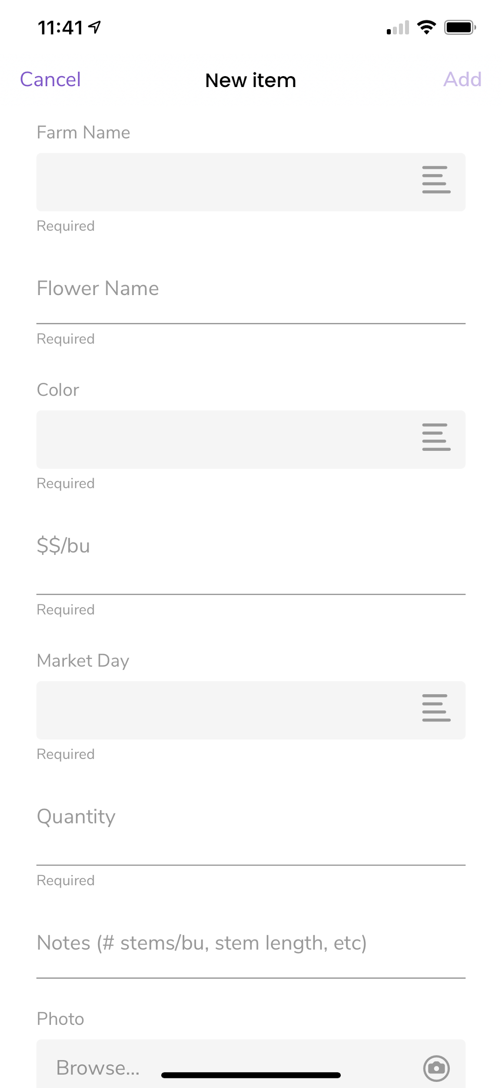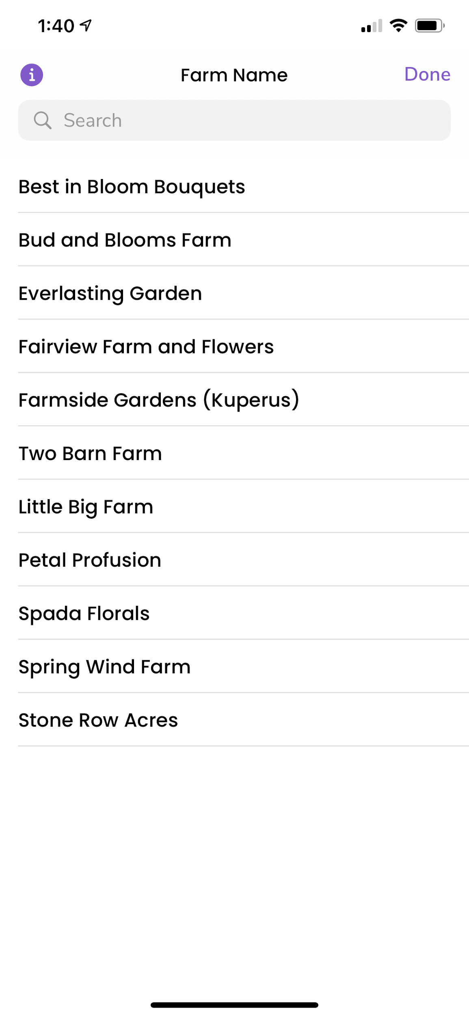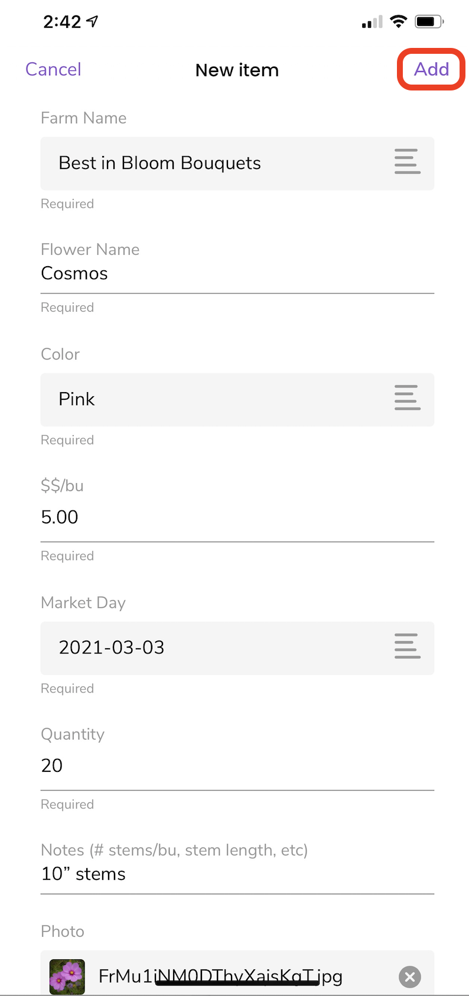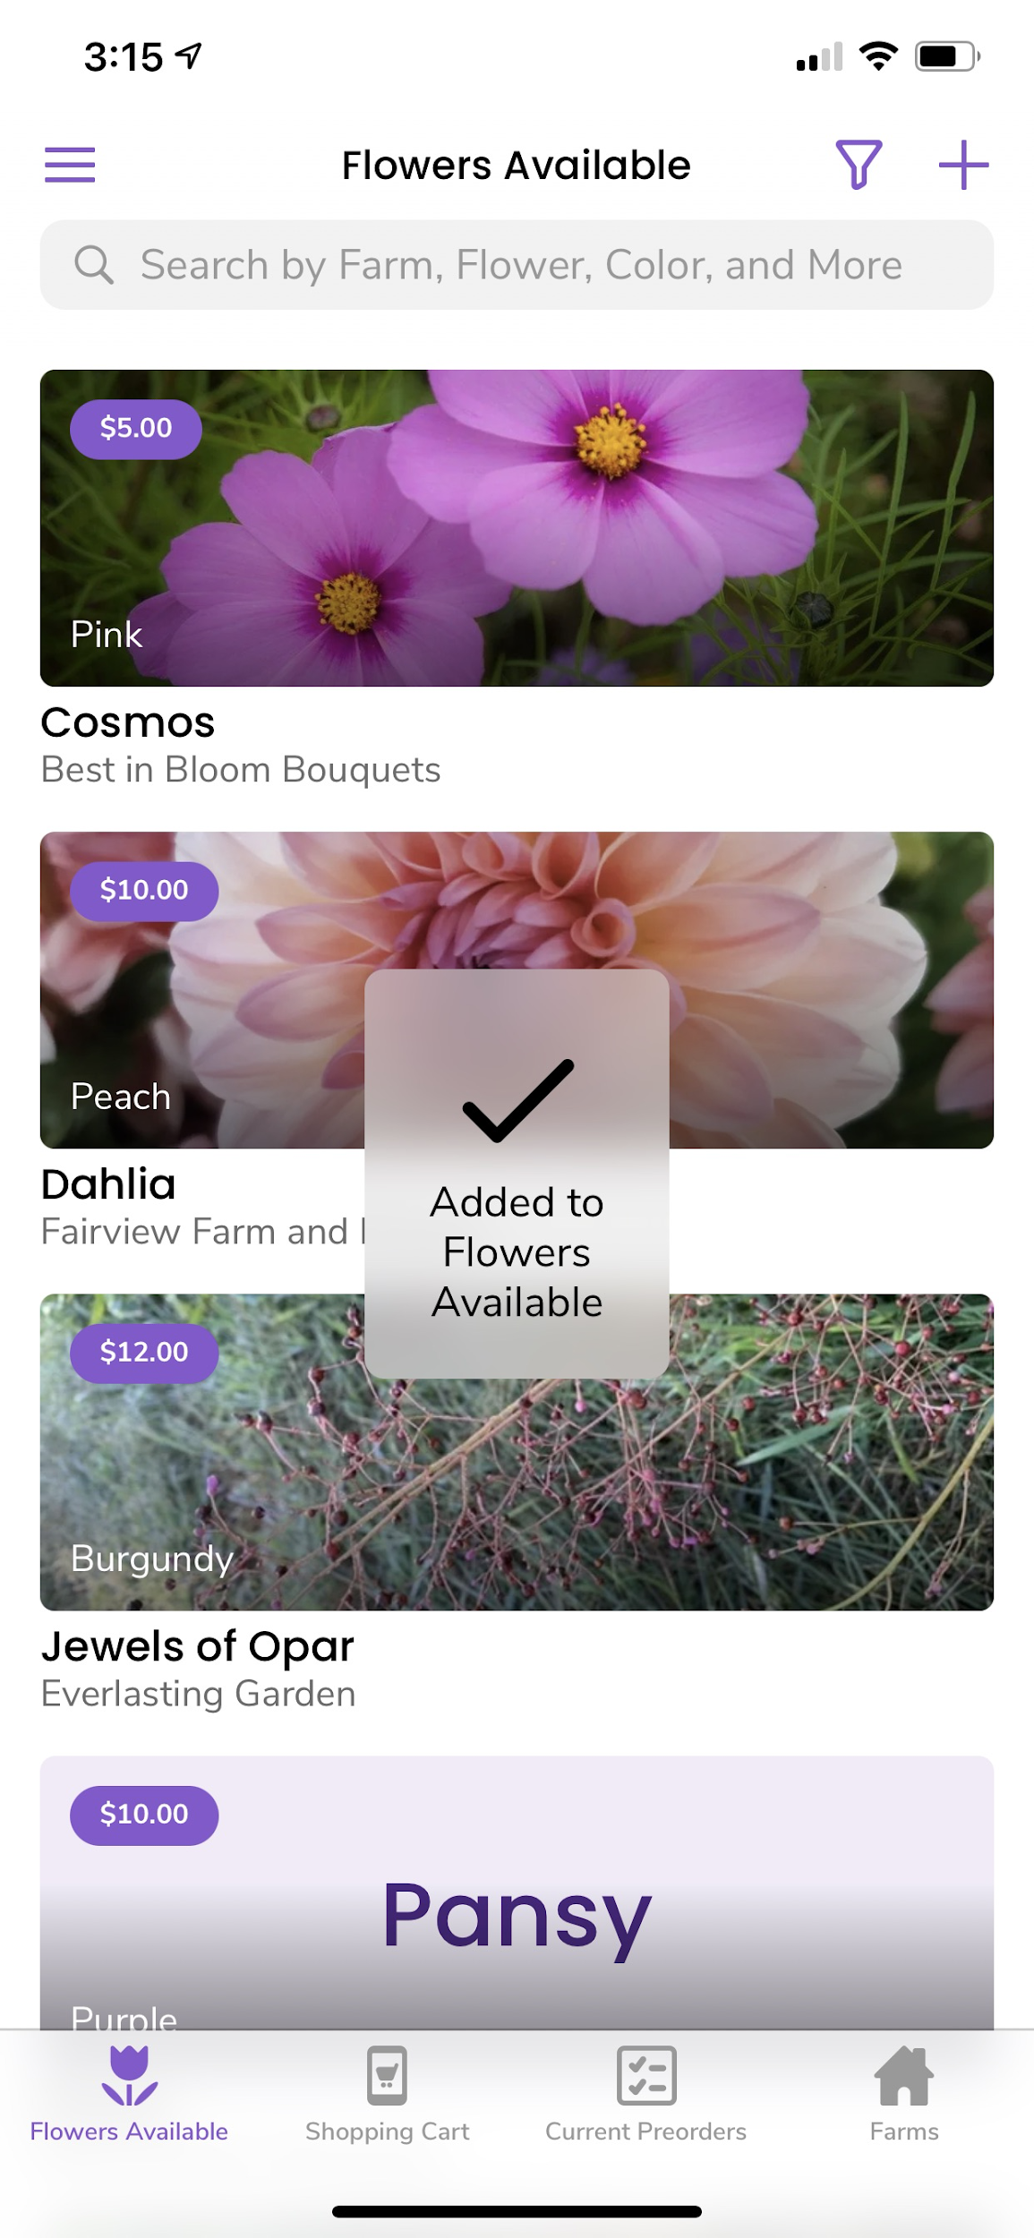

# 

# 

# **Designers:** How to View Flowers for the Upcoming Market Day

In the **“Flowers Available”** section, designers are able to view and place preorders for the upcoming market day between Wednesday at 6:00 am and Saturday at 11:59 pm. Designers can easily search, sort, and filter the flowers currently available.

***Note:*** *Designers will be able to view preorder availability as growers upload their availability from Sunday at 12:01pm through Tuesday at 11:59pm.* ***The ‘Add to Cart’ button will appear beginning at 6am on Wednesdays when you will actually be able to begin placing preorders.***

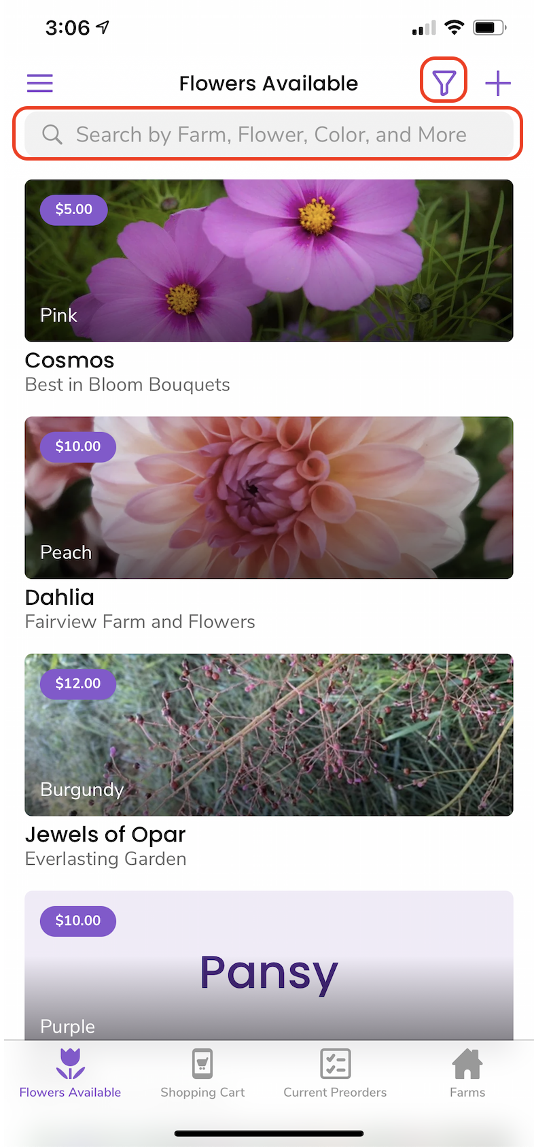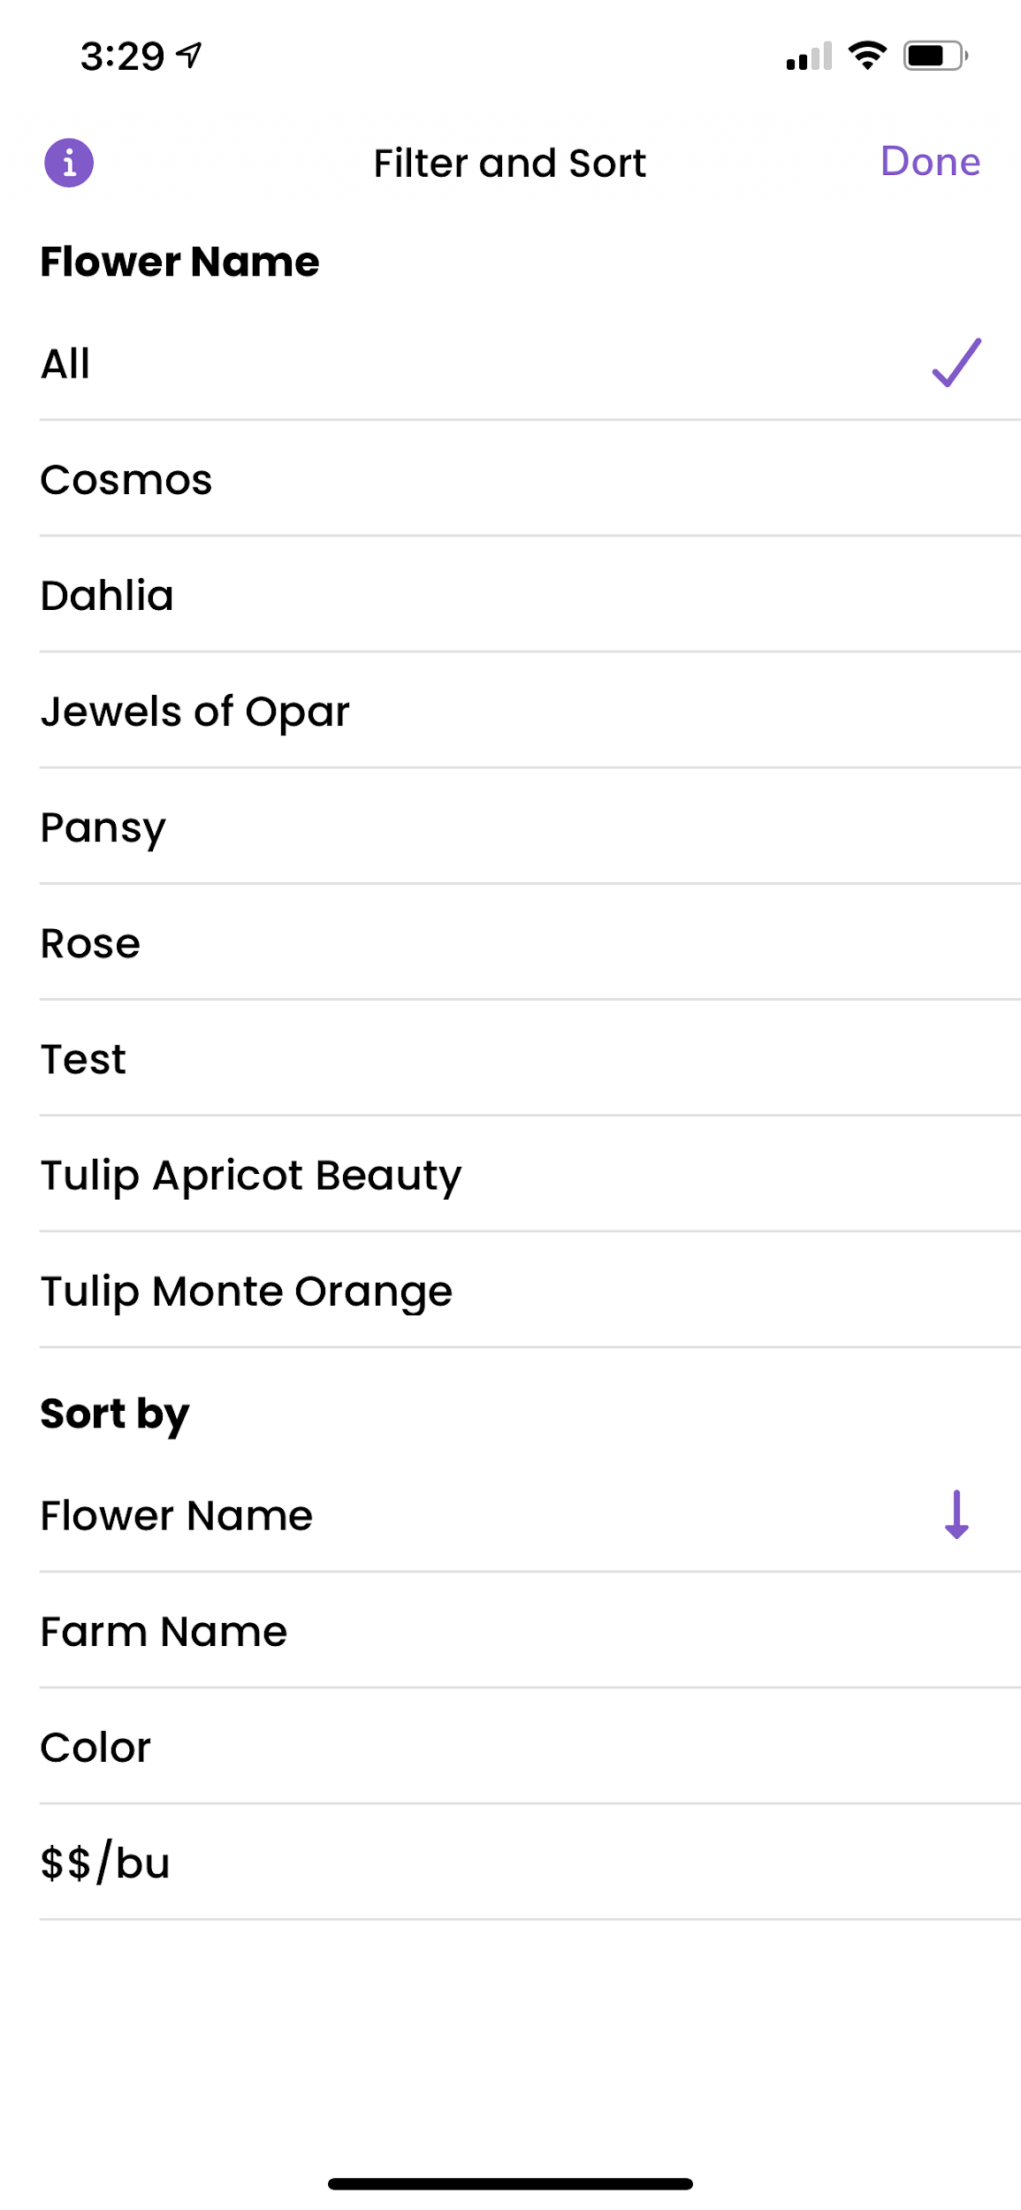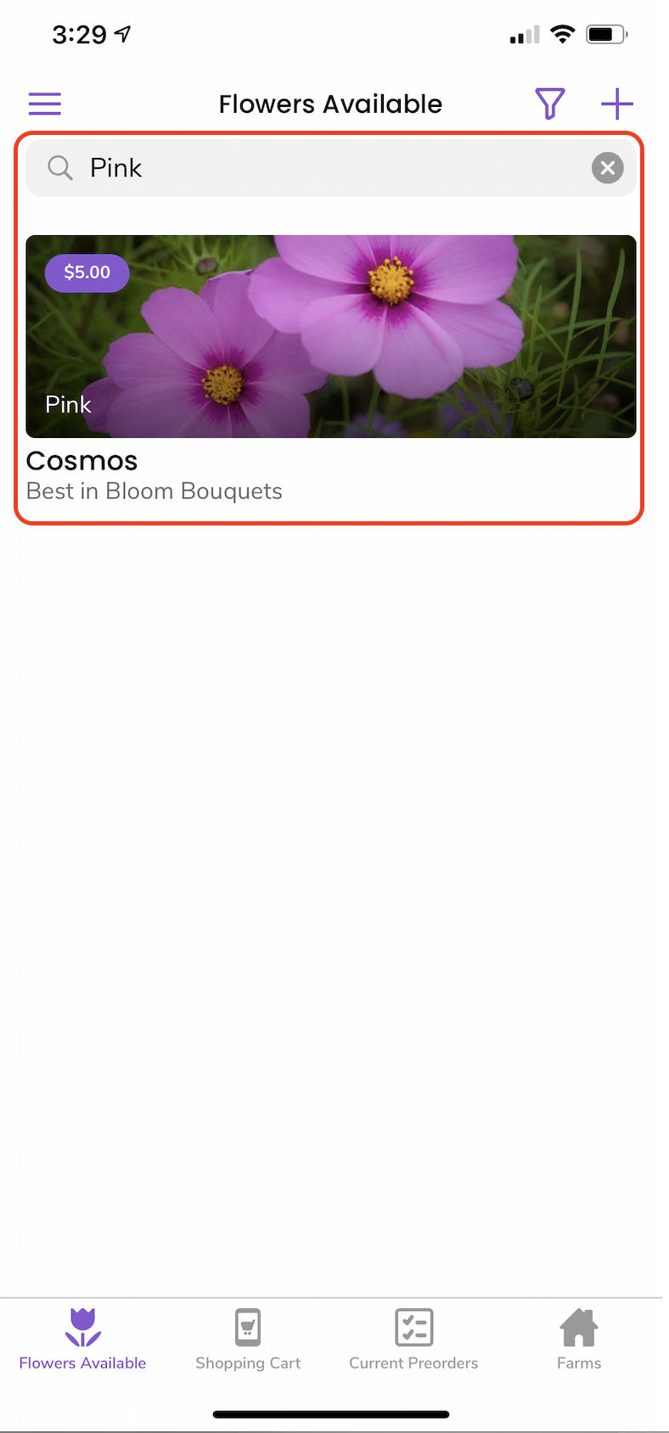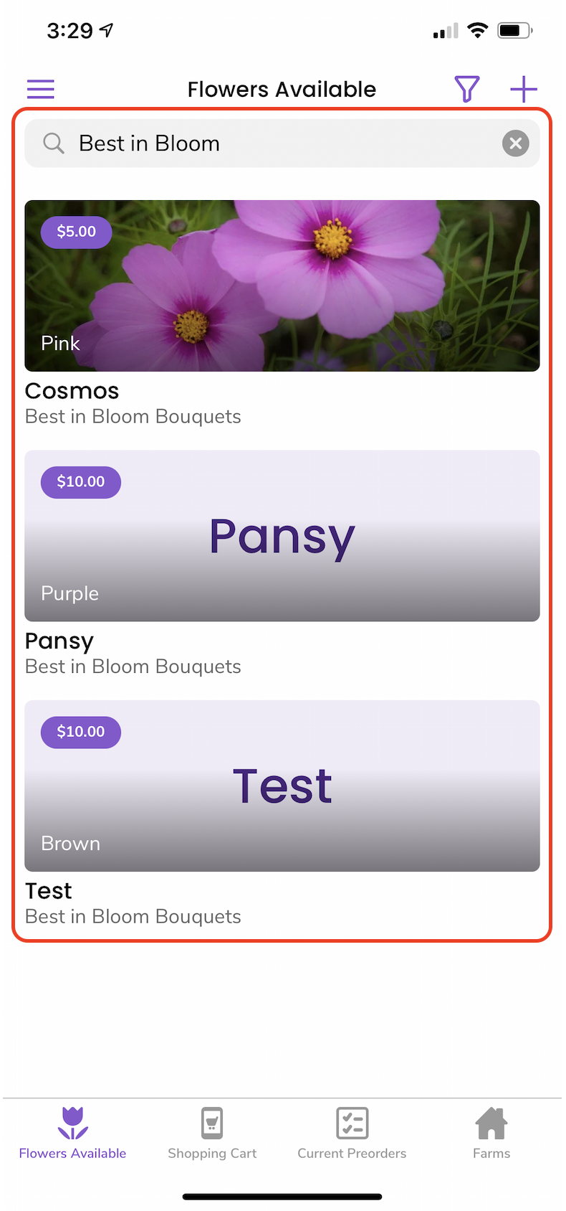

# 

# **Designers:** How to Add Flowers to your Shopping Cart

From the **“Flowers Available”** screen, designers can easily view the upcoming flowers available for the next Market Day. Designers can easily use the search bar to find specific varieties. They can also sort the flower listings by what farm they are being sold by, color, and price. Once they click on a flower listing, designers are presented with additional information about the listing, as well as the ability to add the flower to their shopping cart.

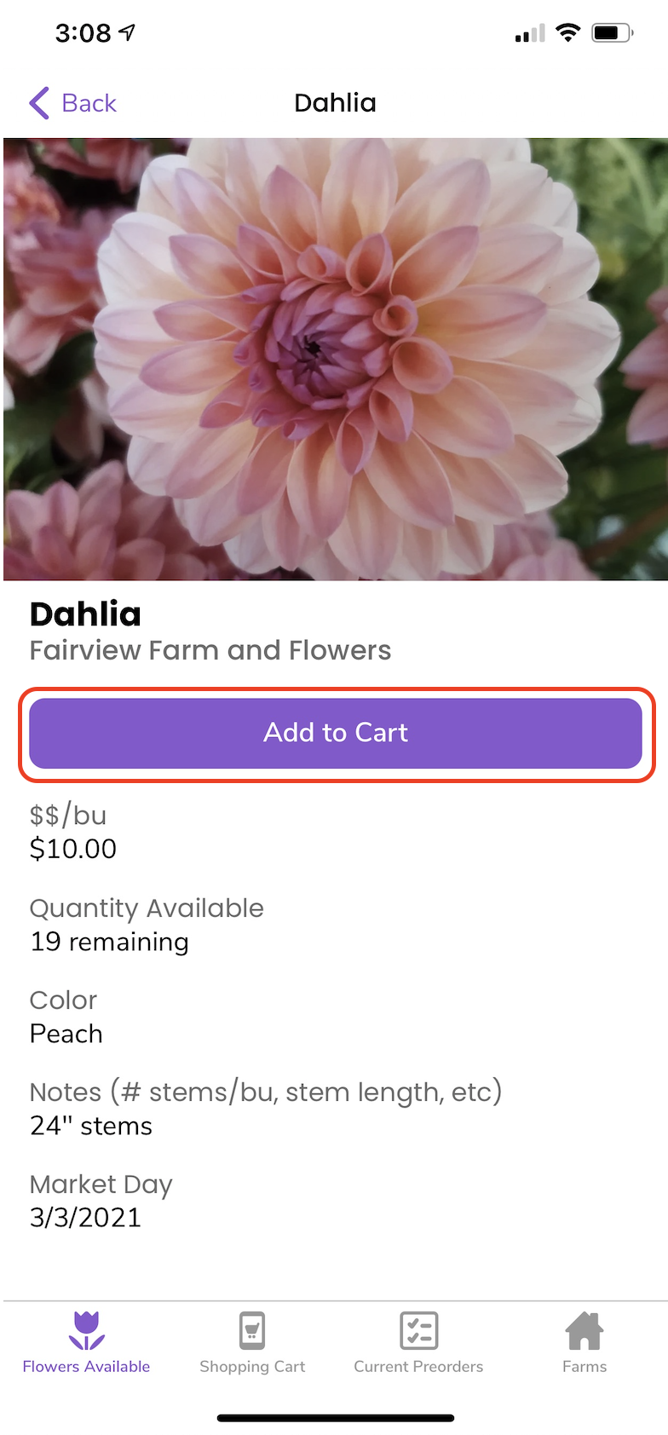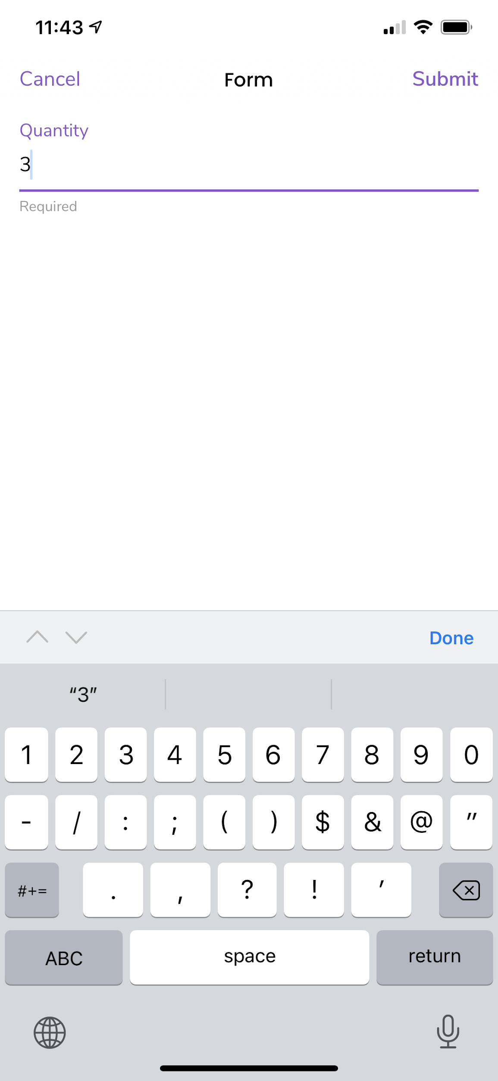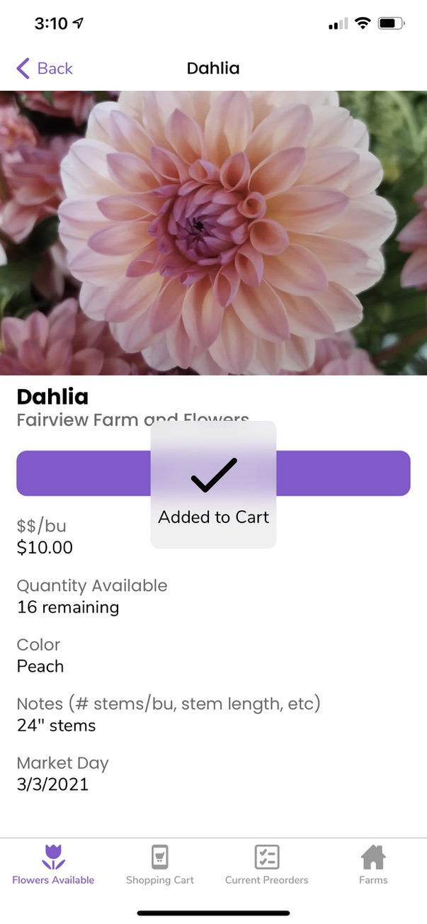

# 

# 

# **Designers:** How to Review and Finalize a Pre-order

Once flowers have been added to the cart, designers have the opportunity to review and edit the quantity before each flower is finalized in the **“Shopping Cart”** section. In order to edit and finalize, each flower in the cart must be selected. The shopping cart’s inventory is grouped by each farm to simplify the process when the Designer reviews their orders. ***Please note: Buyer Name should be your business name and the corresponding business email address.***

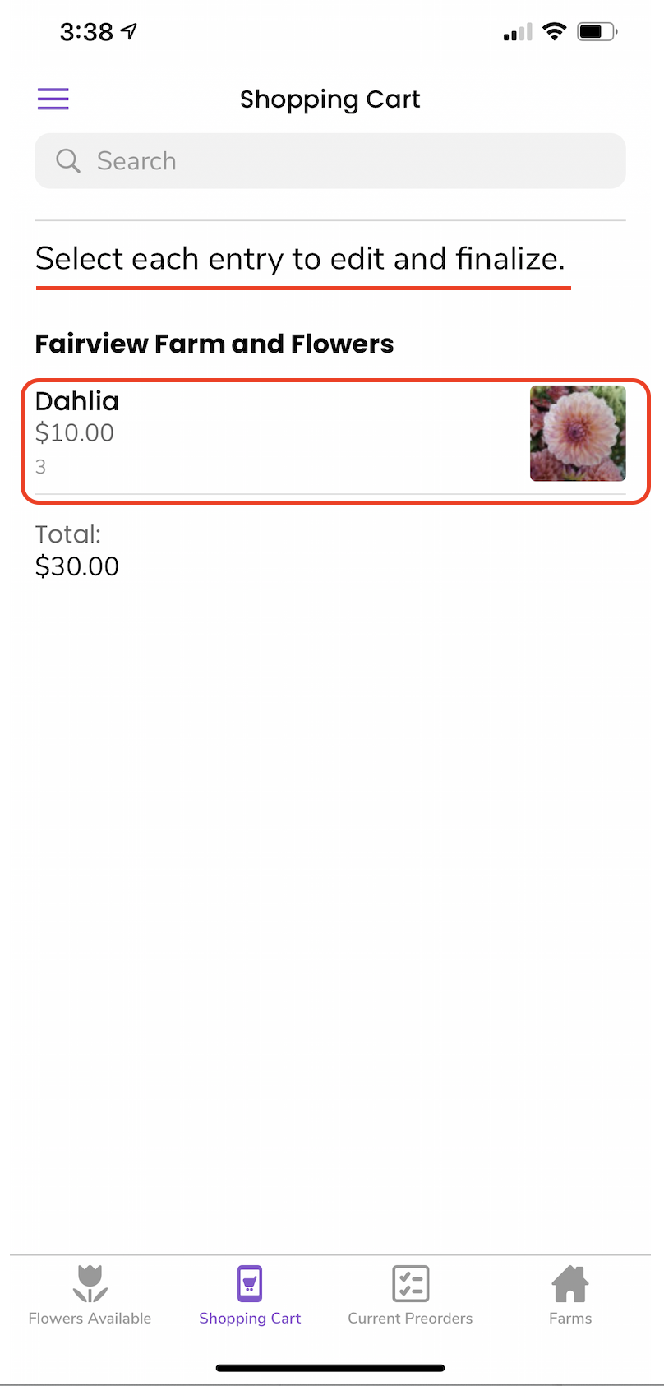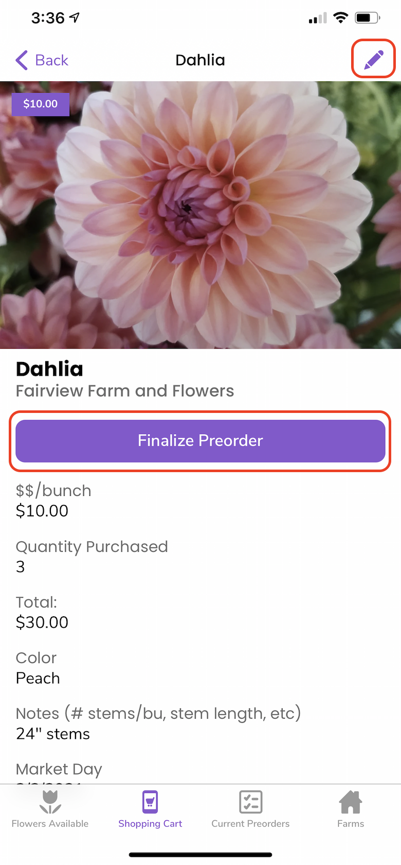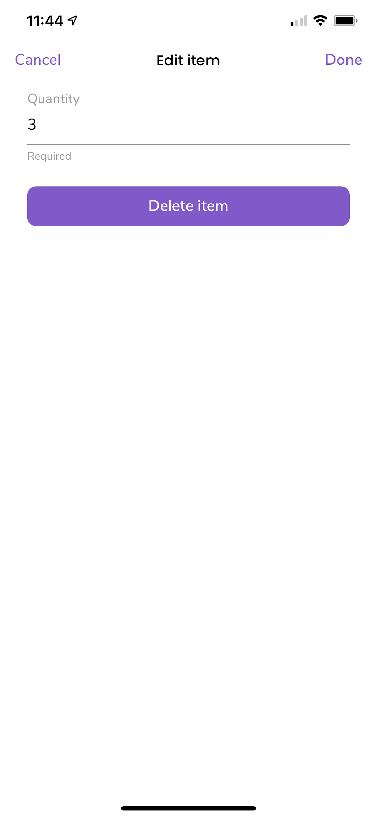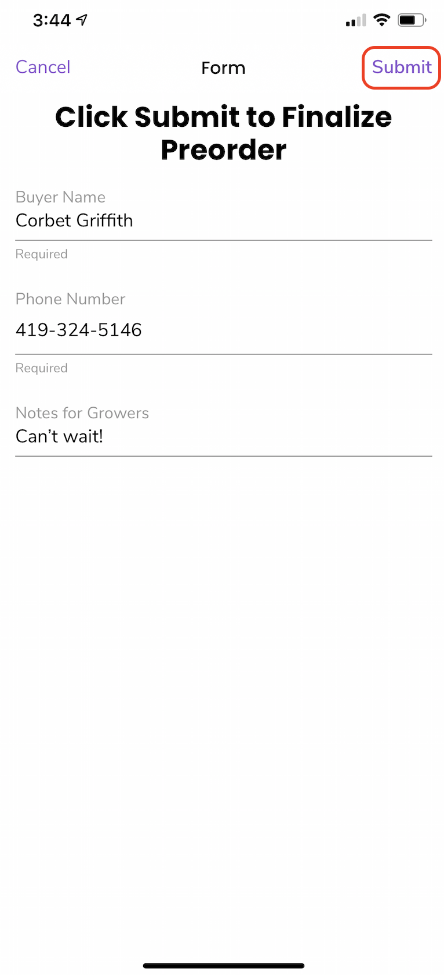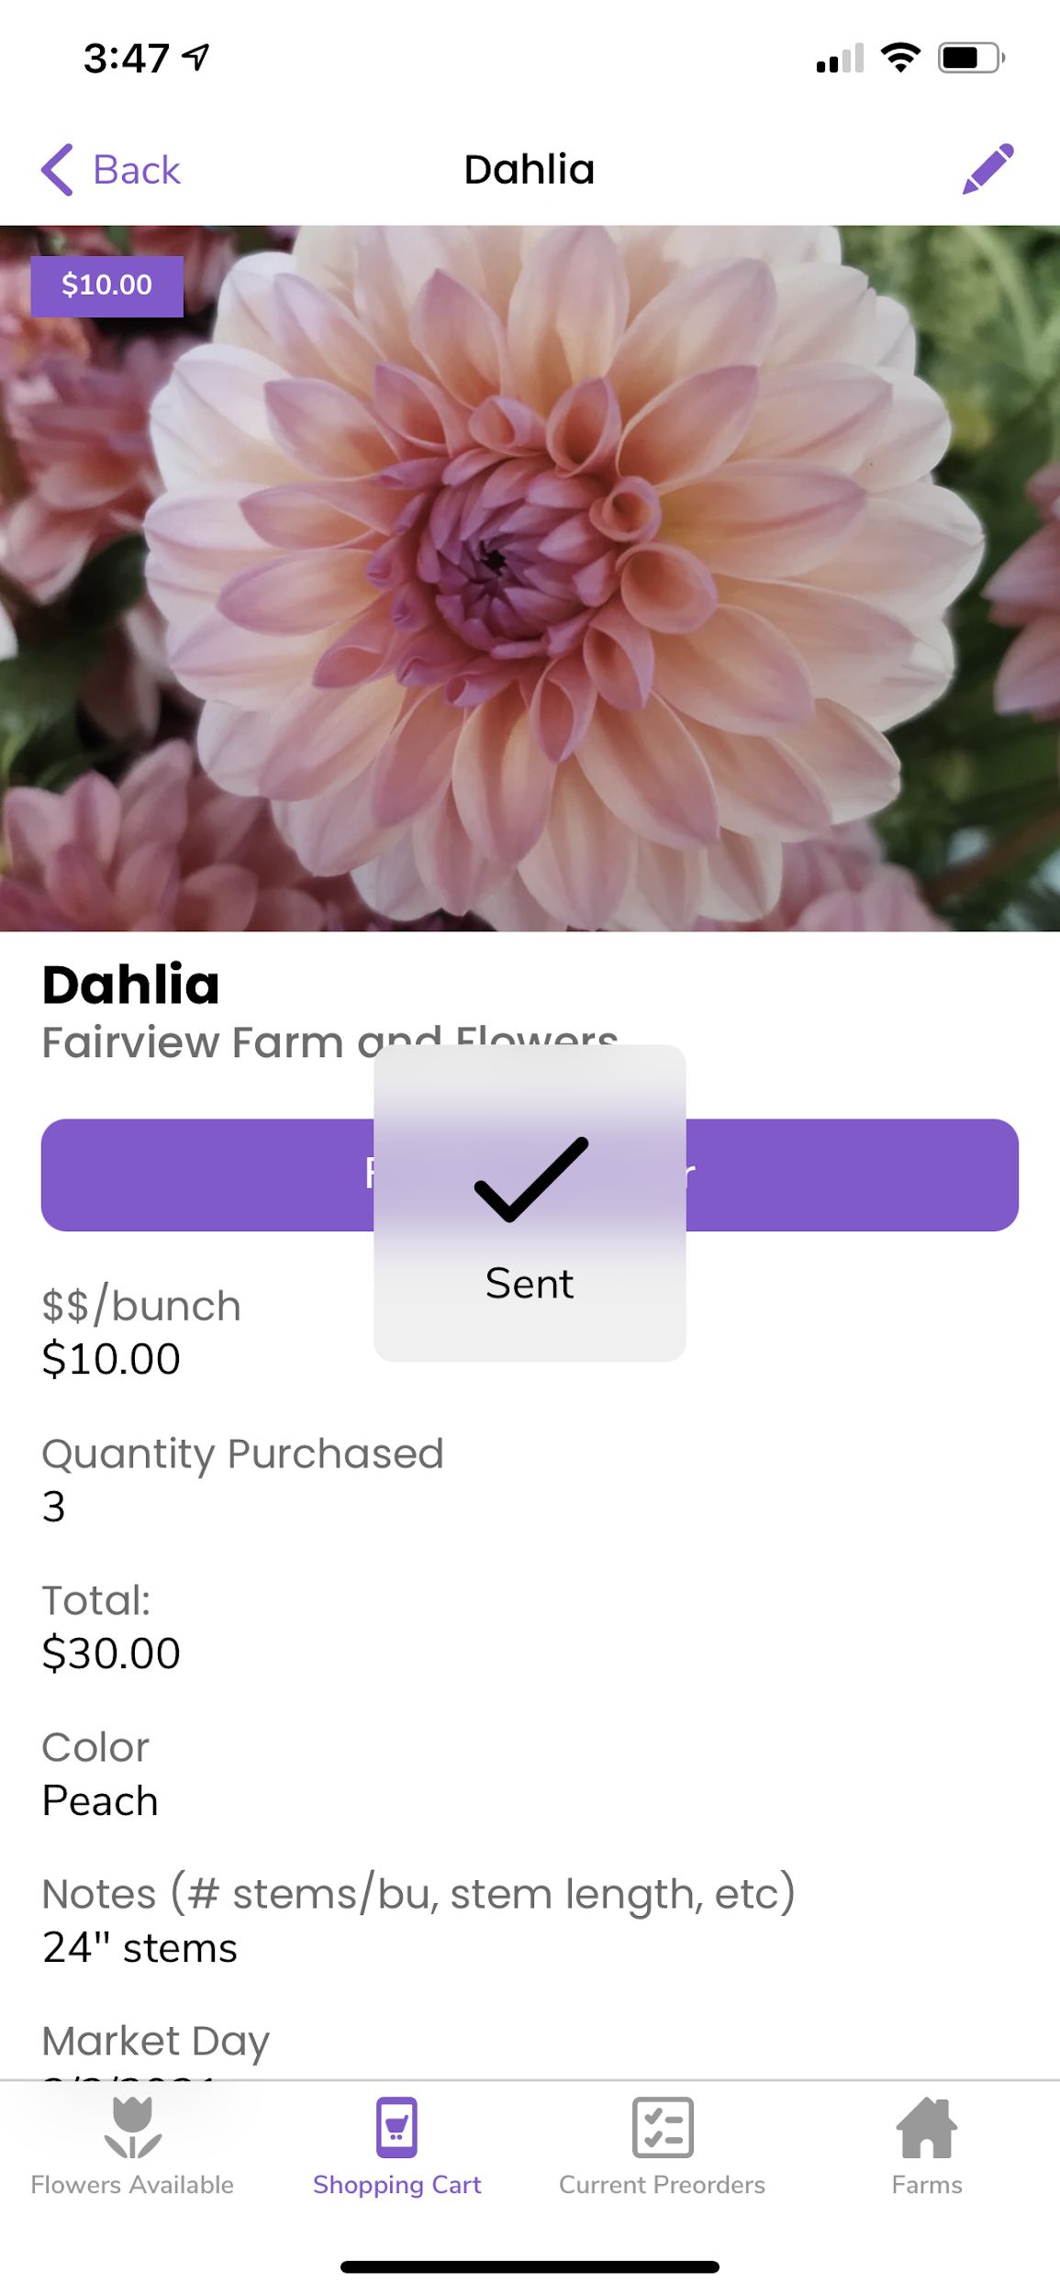

# 

# **Designers:** How to Review Pre-orders

Designers can review the upcoming orders for the Market Day in the **“Current Preorders”** section. Note: Designers cannot make any adjustments after a pre-order has been finalized.

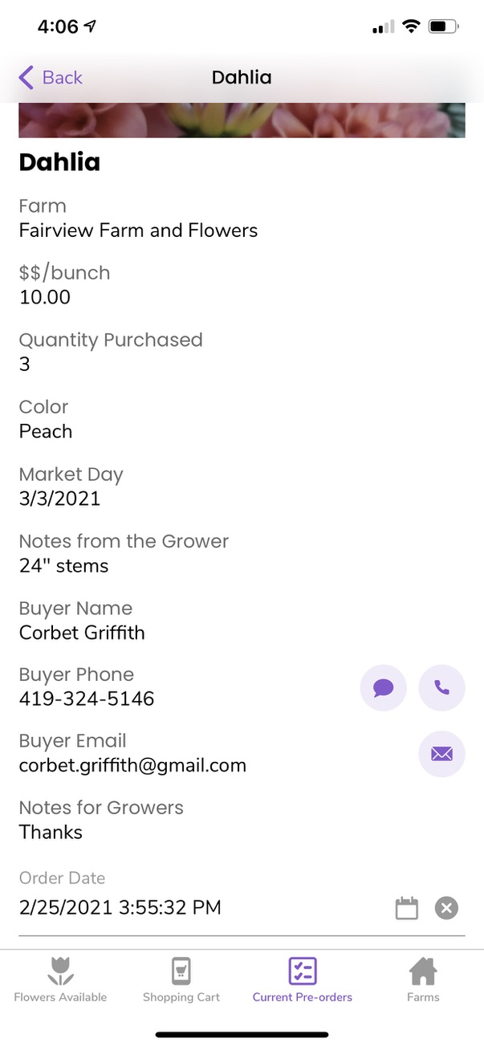

# 

# **Growers:** How to Fulfill a Preorder

Growers can access the **“Fulfill Preorders”** section of the app to review orders for the upcoming Market Day. As growers pack their orders for the market day, they can fulfill the preorder, which archives the order in its final location, the **“Completed Preorders”** section”

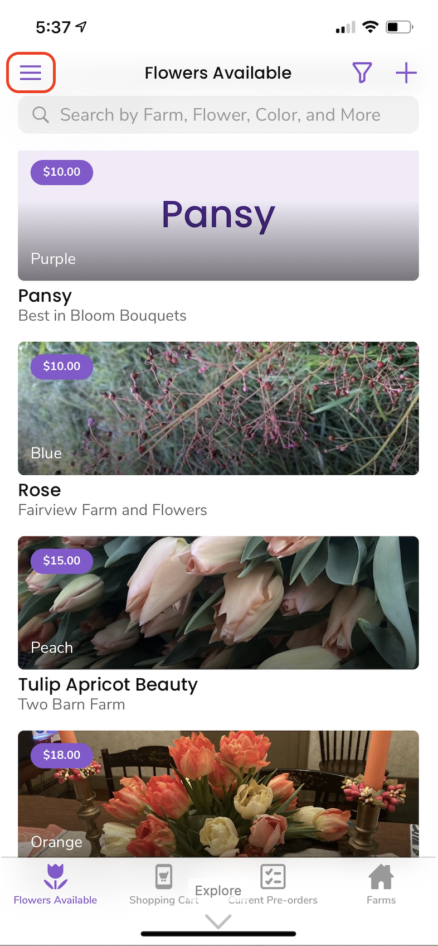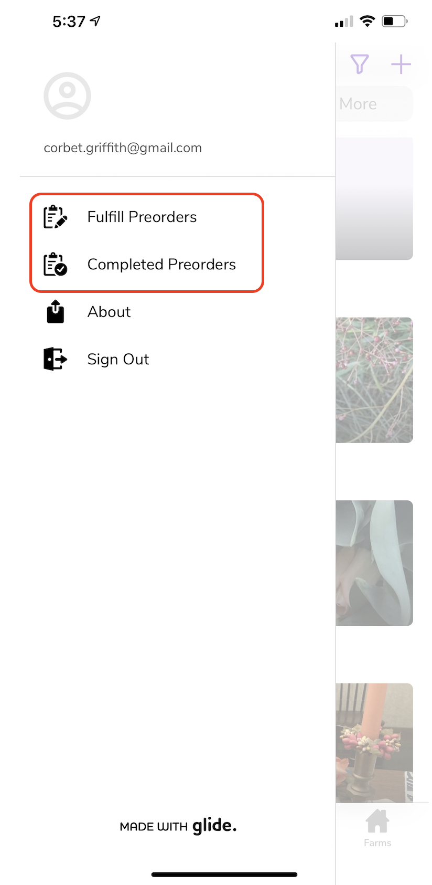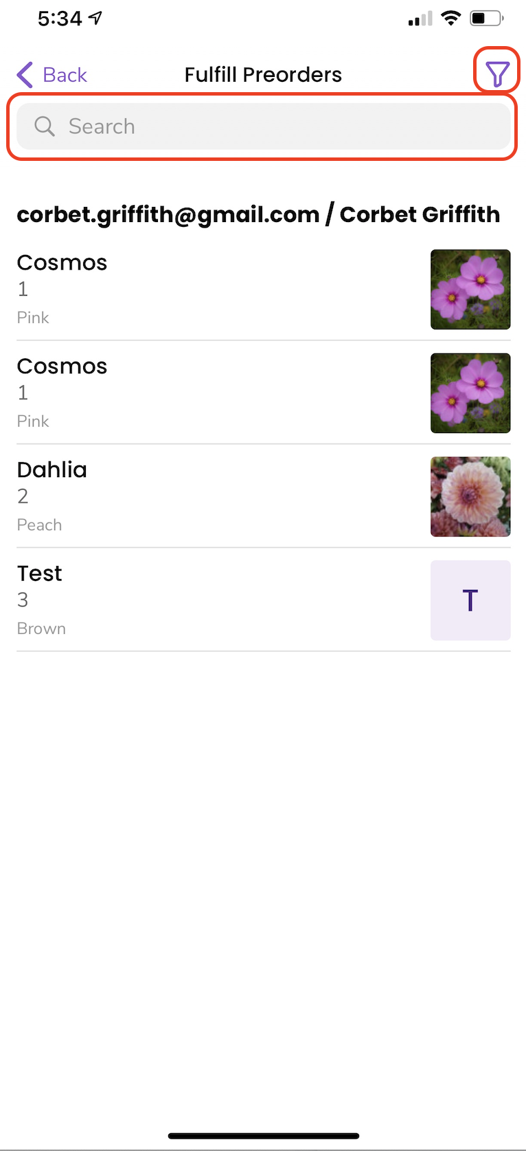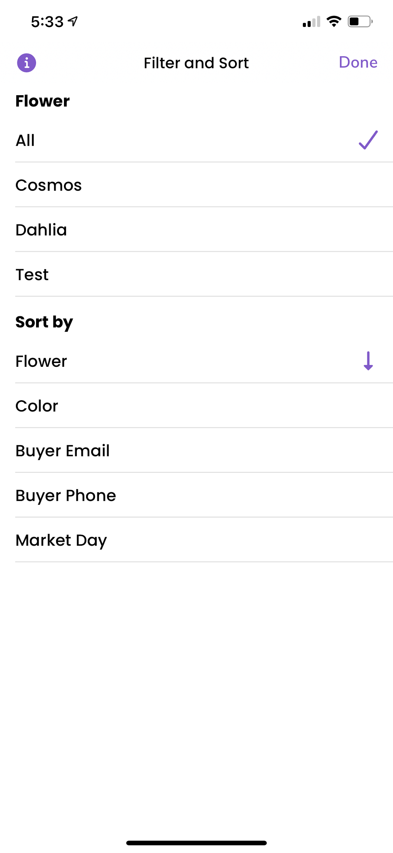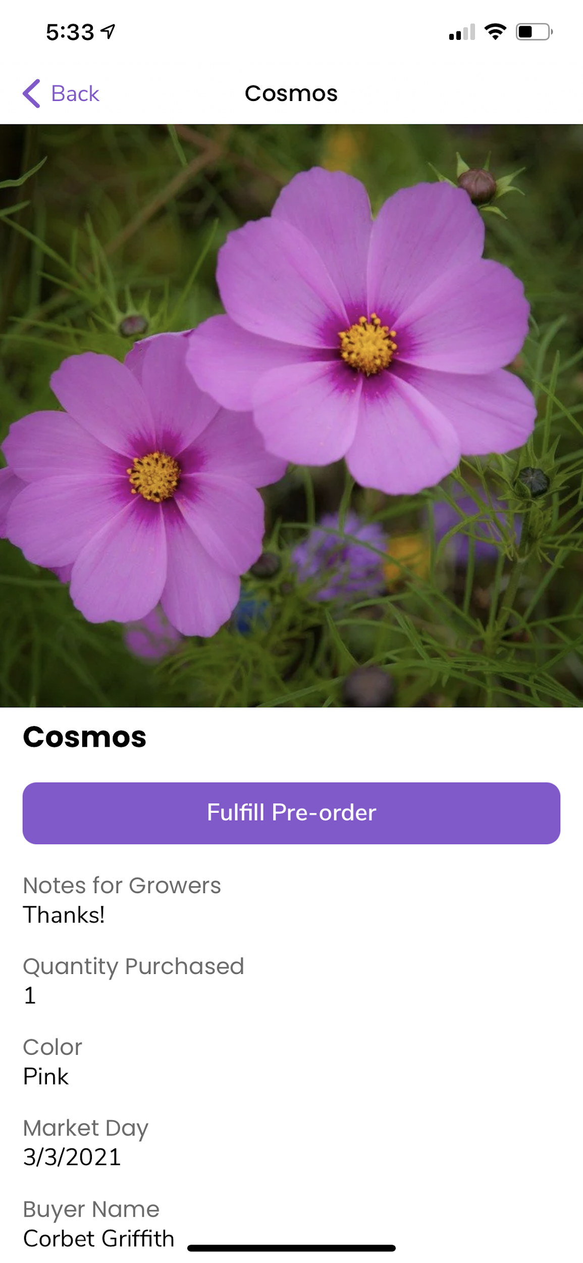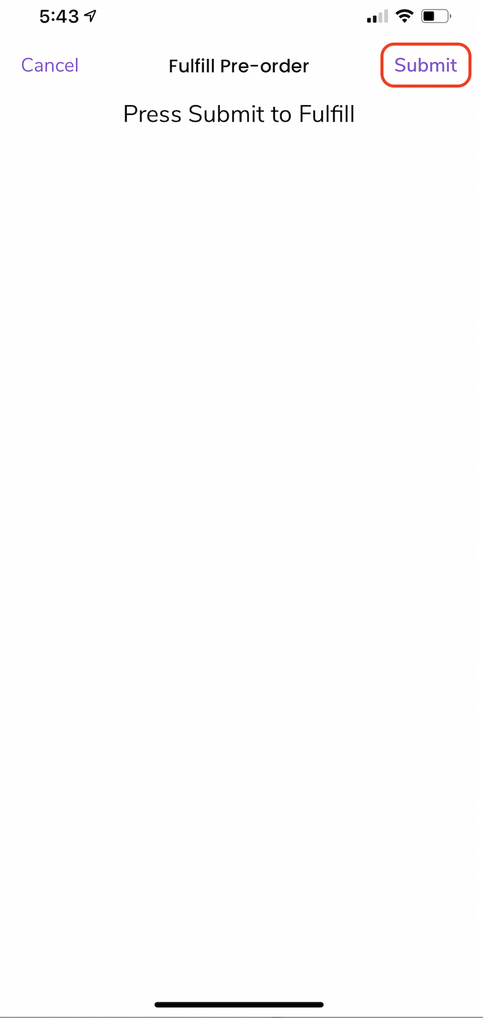

# 

# 

# **Growers:** How to Review Completed Orders

If an older order needs to be reviewed for any reason, it can be viewed in the **“Completed Orders”** section. Previous flowers can even be added back to the “Flowers Available” section for future market days, reducing the amount of time entering existing data.

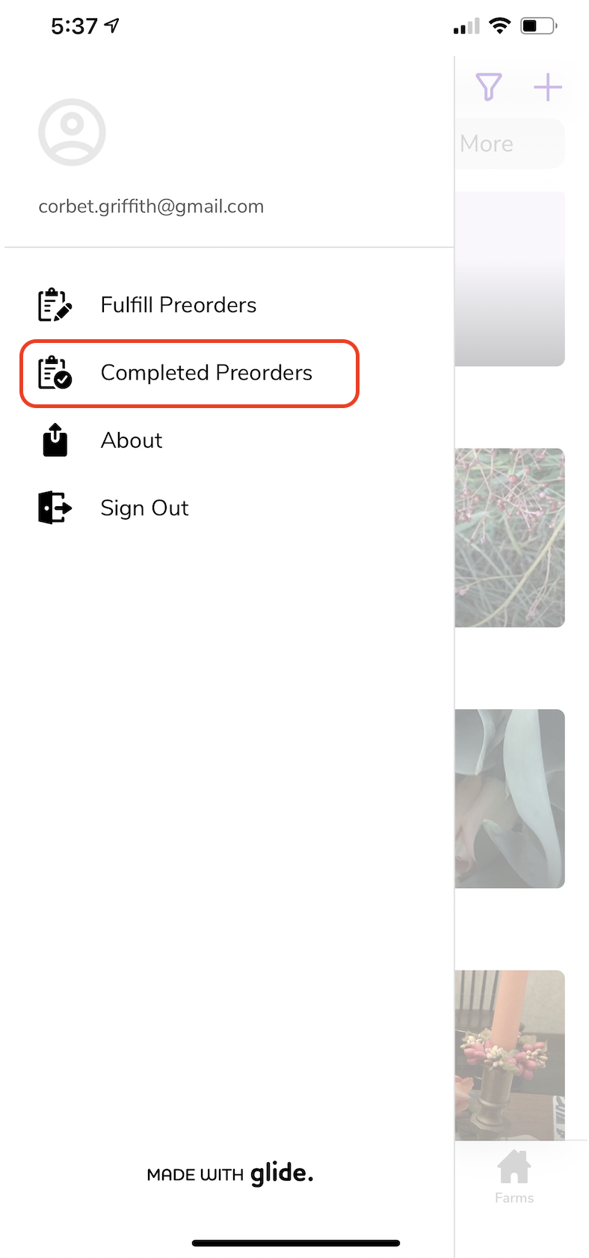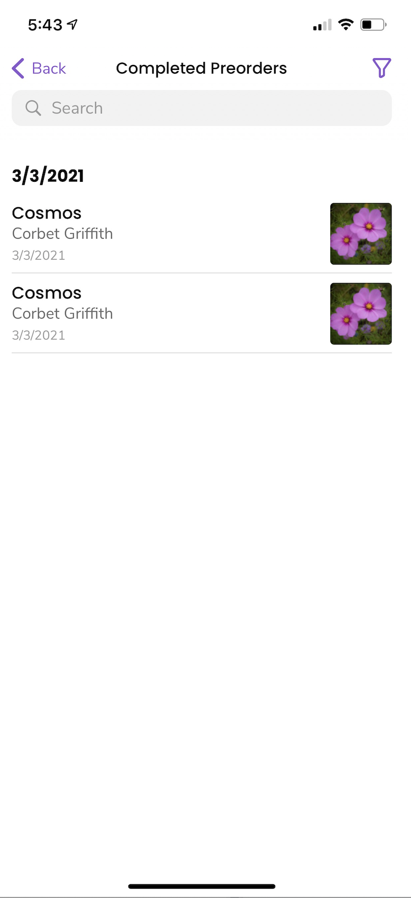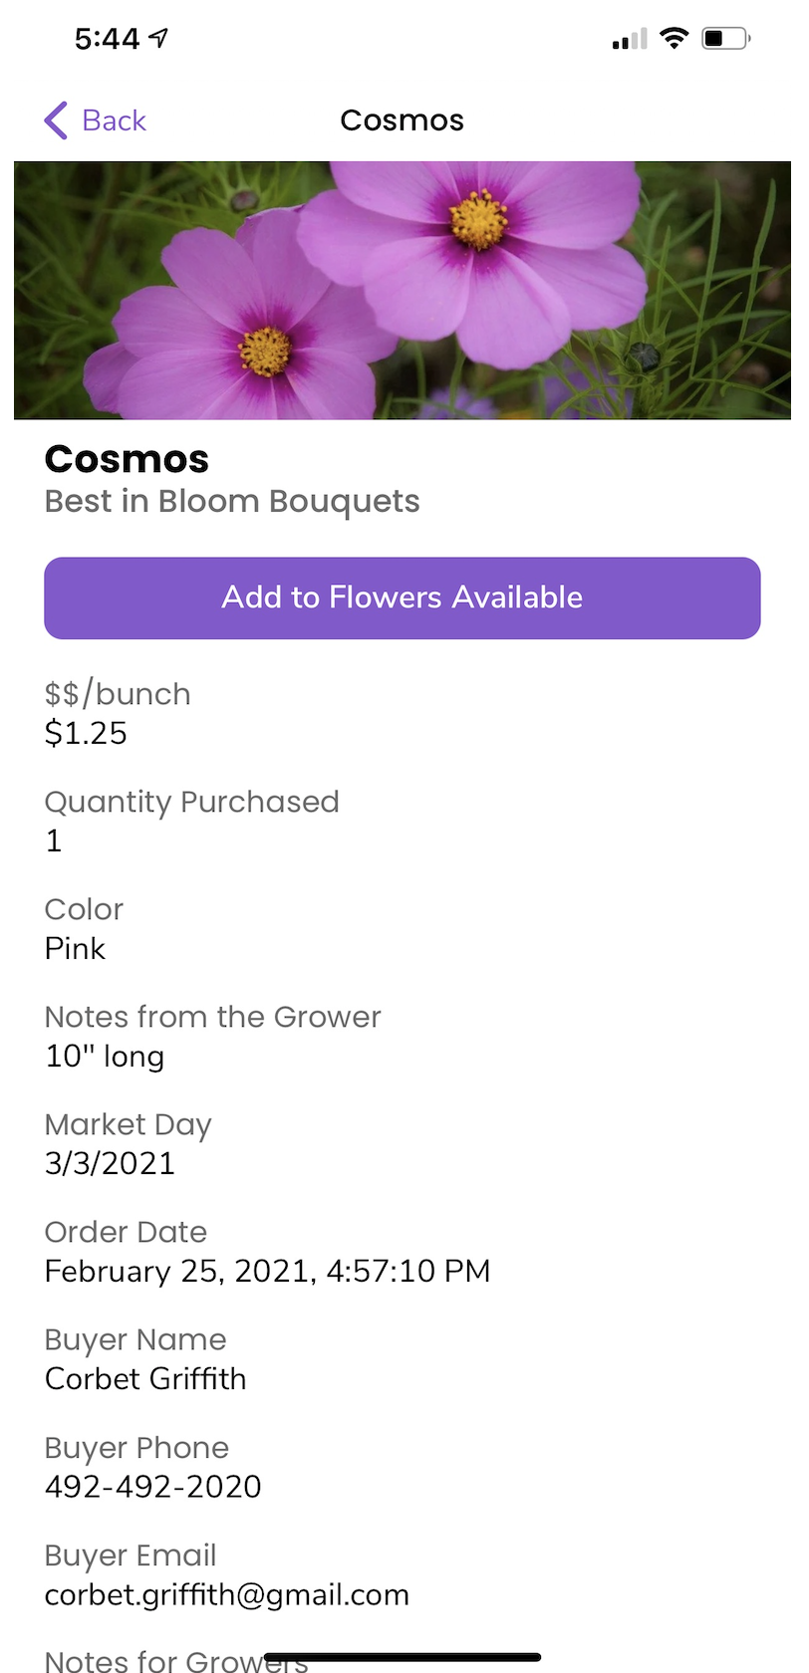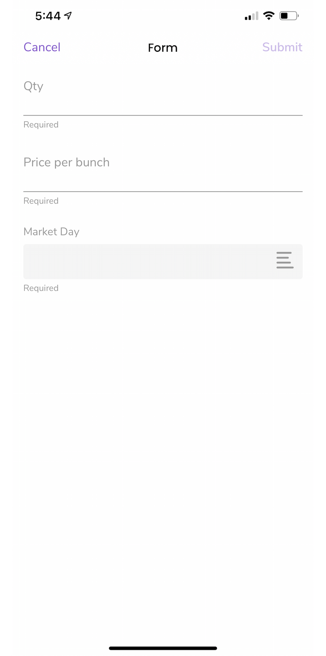

# 

# View a Farm’s Information

Farmers can showcase photos and include links to their website and social media in the **“Farms”** section. Information can be edited by the Farmers, if necessary.

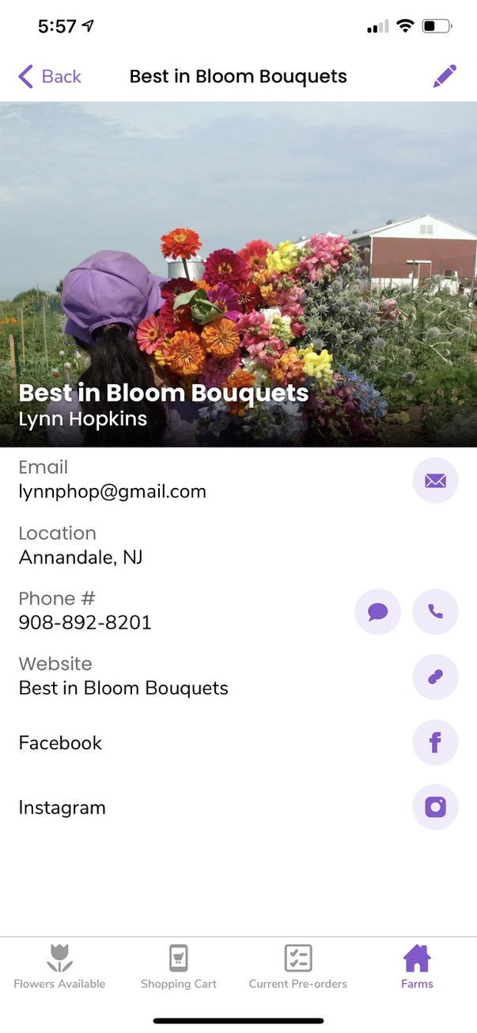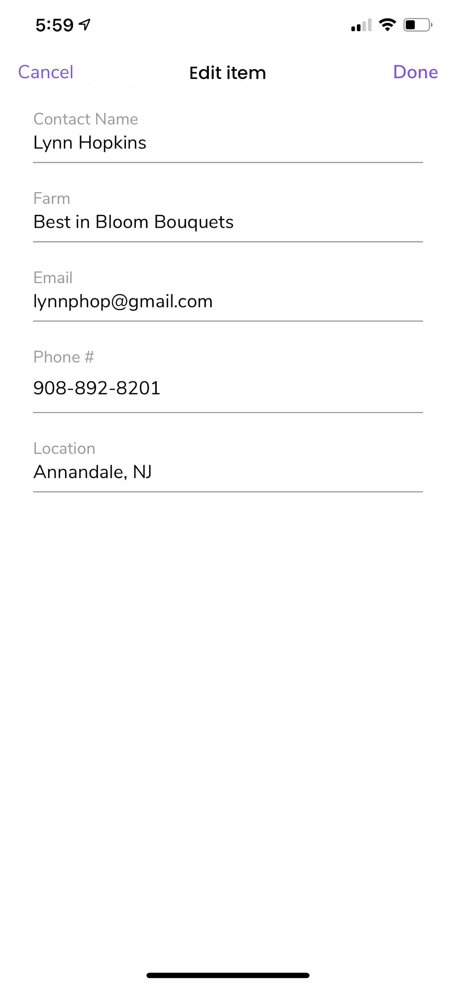

# 

# 

# How to Delete the Webapp from Mobile Device or Tablet

The Preorder webapp can be deleted by finding the icon on your device’s home screen, tapping, and holding the icon until the options overlay is shown. Tap “Delete Bookmark” to delete it.

# 

# 